<https://www.linkedin.com/posts/the-cyber-security-hub_activity-7051002418691477504-jpKt?utm_source=share&utm_medium=member_desktop>

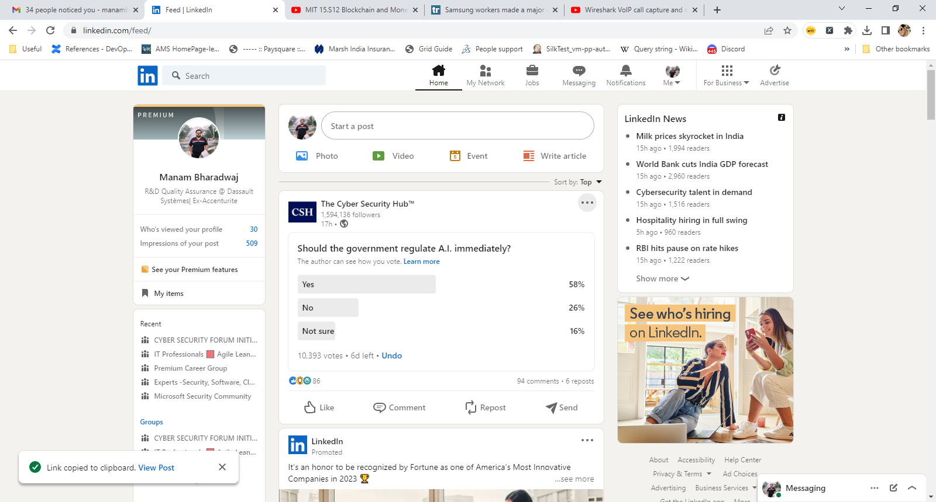

Reasons why I feel it should be regulated:   
  
1. Ethical concerns: AI has the potential to cause harm to society if it is not used ethically. For example, if an AI system is used to make decisions about who gets access to healthcare or social services, it could discriminate against certain groups. Regulation can ensure that AI is used in an ethical and responsible manner.  
  
2. Safety concerns: AI systems can be dangerous if they malfunction or are hacked. For example, a self-driving car could cause a fatal accident if it malfunctions. Regulation can ensure that AI systems are designed to be safe and secure.  
  
3. Accountability: AI systems are often opaque, which can make it difficult to hold them accountable for their actions. For example, if an AI system is used to make decisions about hiring or promotion, it may be difficult to determine if the system is biased. Regulation can ensure that AI systems are transparent and accountable.  
  
4. Economic concerns: AI has the potential to disrupt entire industries and displace workers. Regulation can ensure that the benefits of AI are distributed fairly and that workers are protected from displacement.

…………….

<https://www.techradar.com/news/samsung-workers-leaked-company-secrets-by-using-chatgpt?s=09>

………………..

<https://www.dailymail.co.uk/news/crime/article-11665797/Paedophiles-using-AI-art-generators-create-child-porn.html>

…………………….